1/ ECG_108

|  |  |  |  |  |
| --- | --- | --- | --- | --- |
| Algorithm | Data | Param | Anomalies | Time |
| VL with Qudratic | (0-21600) | e1 = 3.0, e2 = 0.3, k =1, alpha = 3 | (10870 - 10951) | 00:01:24 |
| VL with Extrem Points | (0-21600) | R=1.04,MinLength = 50, k = 1, alpha = 3 | (10850 - 11454) (19579 - 20357)( 9962 - 10518) (4088 – 4534) | 00:12:19 |
| HotSax | (0-21600) | Length = 128, PAA Length = 8 | 10857 | 00:12:54 |

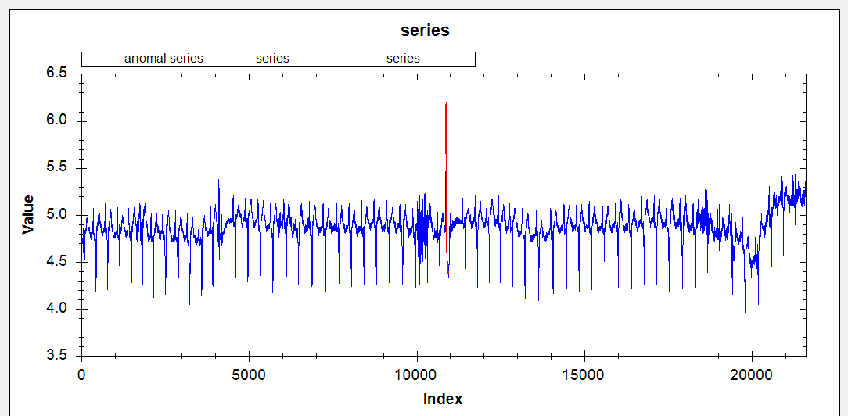

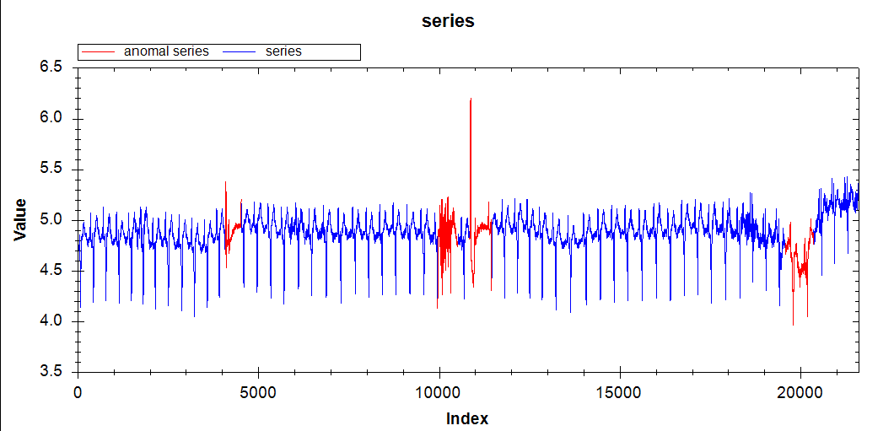

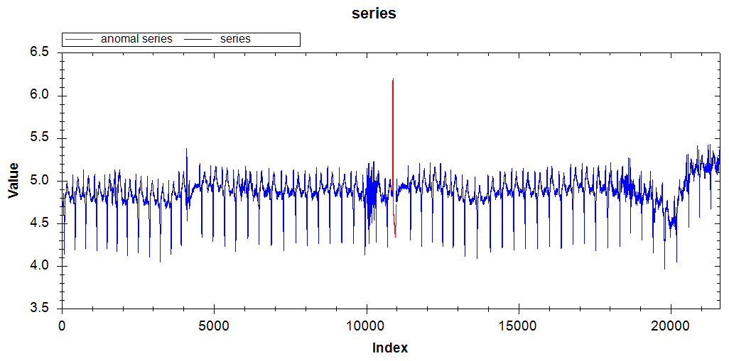

2/ ECG 308

|  |  |  |  |  |
| --- | --- | --- | --- | --- |
| Algorithm | Data | Param | Anomalies | Time |
| VL with Qudratic | (0-1300) | e1 = 40000, e2 = 50, k =1, alpha = 2 | (685-727) | 00:00:01 |
| VL with Extrem Points | (0-1300) | R=1.05,MinLength = 5, k = 1, alpha = 2 | (673-694) | 00:00:04 |
| HotSax | (0-1300) | Length = 30, PAA Length = 3 | 684 | 00:00:10 |

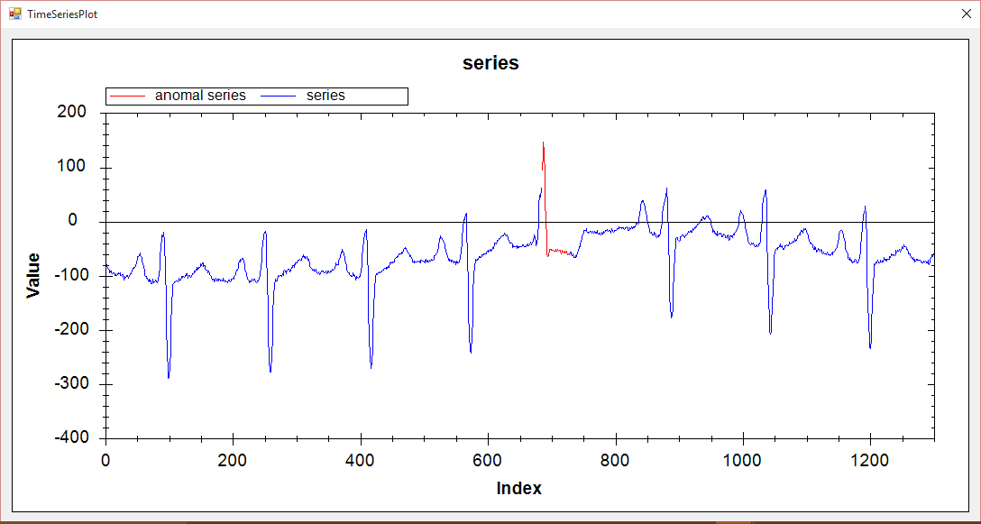

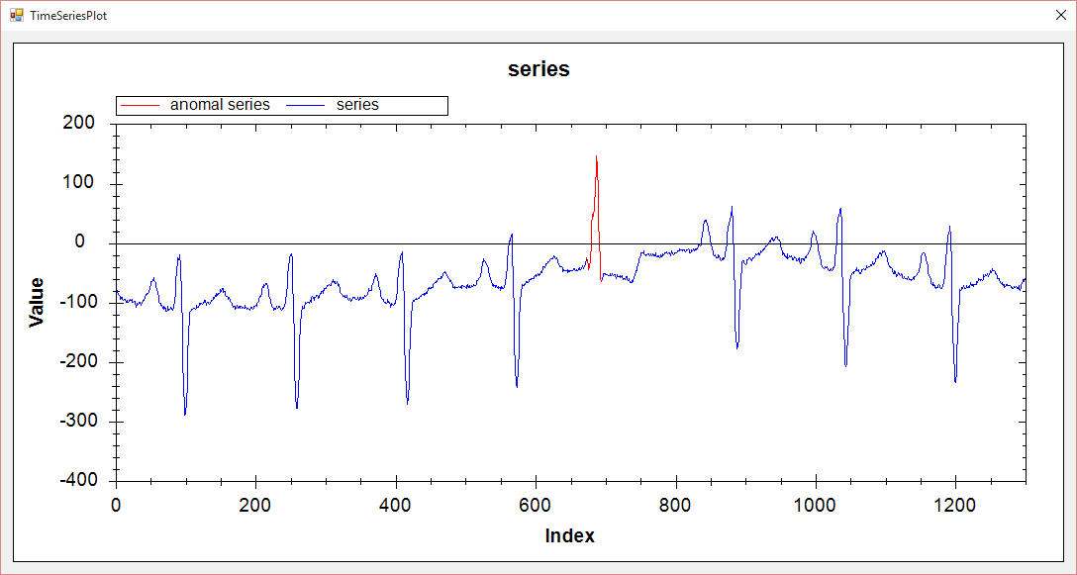

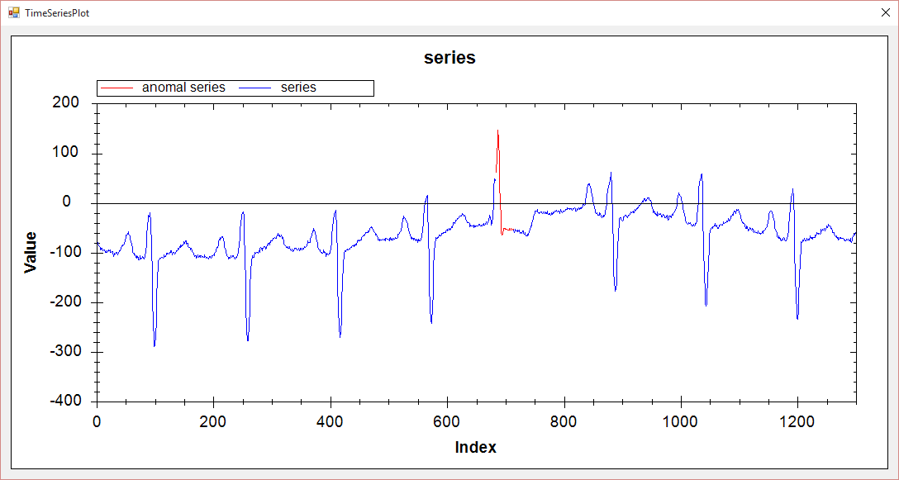

3/ Memory

|  |  |  |  |  |
| --- | --- | --- | --- | --- |
| Algorithm | Data | Param | Anomalies | Time |
| VL with Qudratic | (0-6875) | e1 = 8, e2 = 0.1, k =1, alpha = 2.6 | (2425-2590) | 00:00:14 |
| VL with Extrem Points | (0-6875) | R=1.05,MinLength = 10, k = 1, alpha = 2.5 | (2399-2614)(6271-6433) | 00:01:38 |
| HotSax | (0-6875) | Length = 200, PAA Length = 20 | 2421 | 00:01:19 |

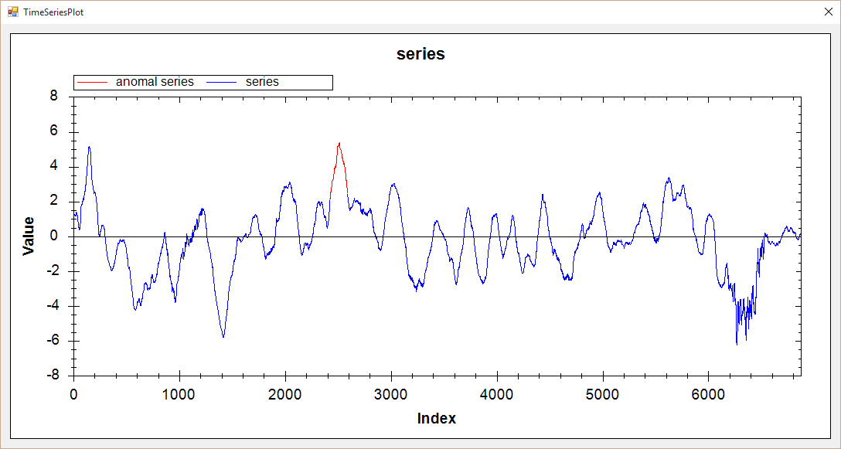

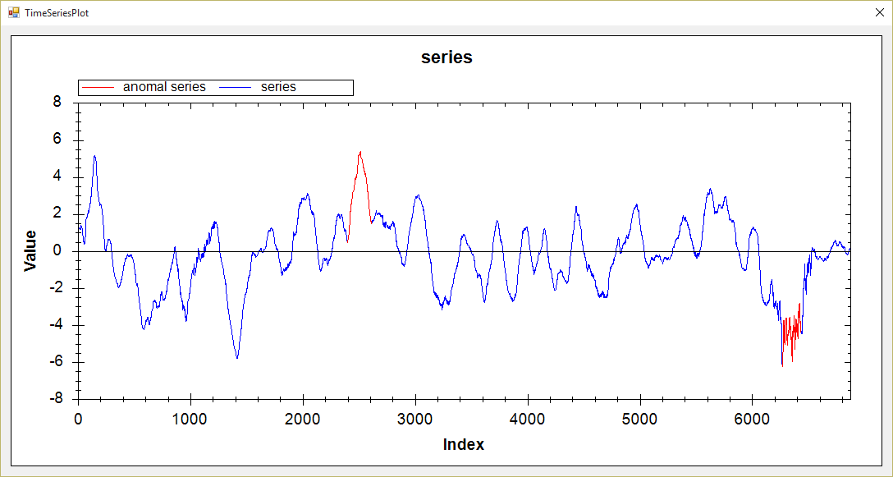

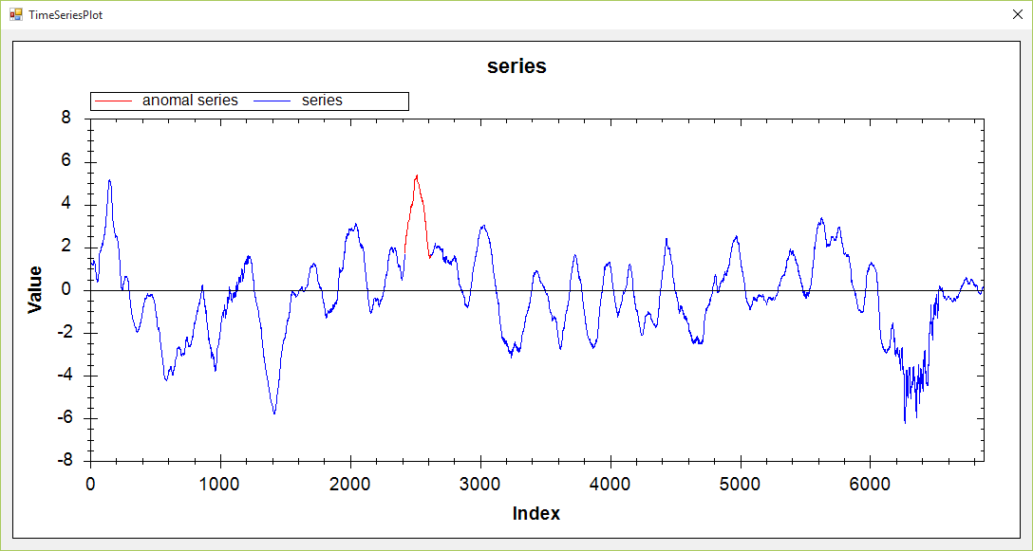

4/ Power demand Italia

|  |  |  |  |  |
| --- | --- | --- | --- | --- |
| Algorithm | Data | Param | Anomalies | Time |
| VL with Qudratic | (0-7000) | e1 = 100000, e2 = 100, k =1, alpha = 4.0 | (5331-5663) | 00:00:47 |
| VL with Extrem Points | (0-7000) | R=1.8,MinLength = 20, k = 1, alpha = 3 | (5383-5719) | 00:01:25 |
| HotSax | (0-7000) | Length = 300, PAA Length = 30 | 5343 | 00:01:42 |

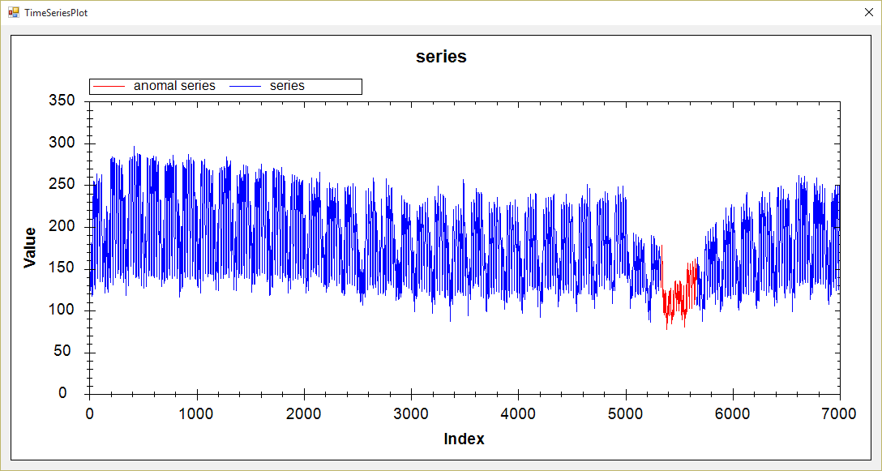

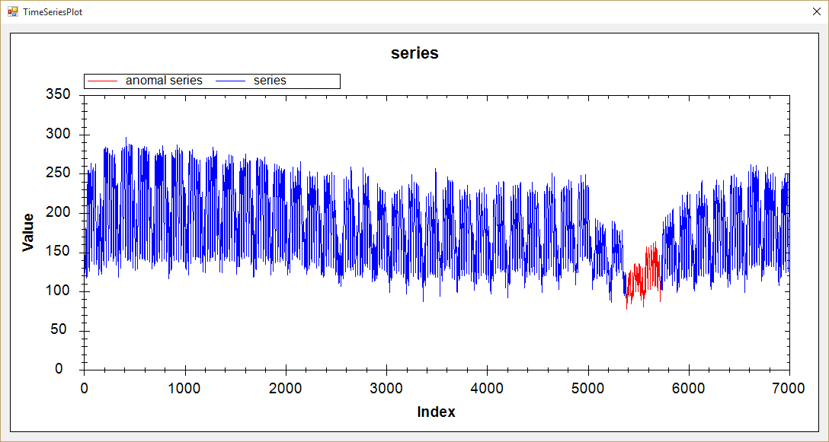

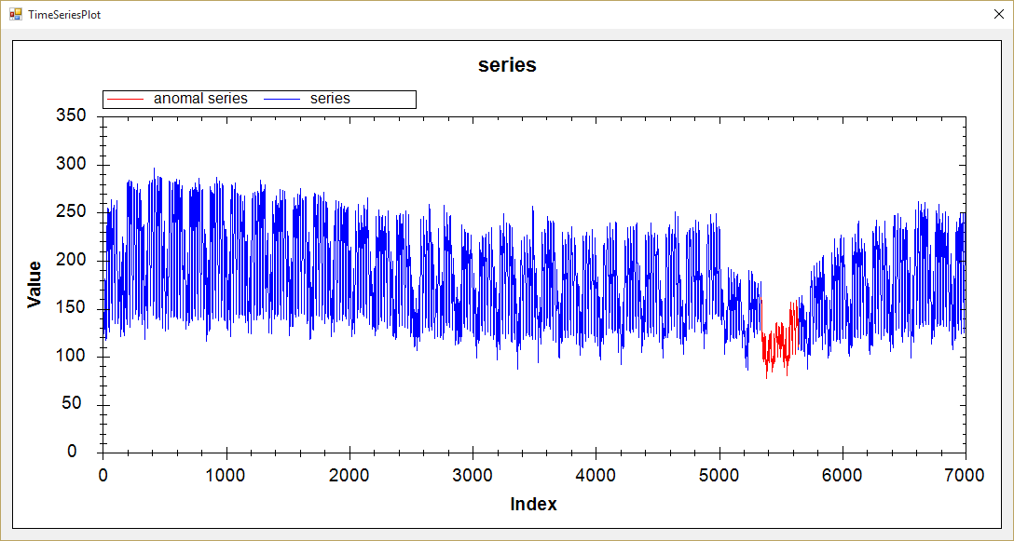

5/ Power Demand Dustch

|  |  |  |  |  |
| --- | --- | --- | --- | --- |
| Algorithm | Data | Param | Anomalies | Time |
| VL with Qudratic | (0-15000) | e1 = 35000000, e2 = 500, k =1, alpha = 2.0 | (11396-12760) | 00:00:30 |
| VL with Extrem Points | (0-15000) | R=1.7,MinLength = 180, k = 1, alpha = 1.7 | (11277-12544) | 00:03:23 |
| HotSax | (0-15000) | Length = 1200, PAA Length = 120 | 11412 | 00:07:02 |

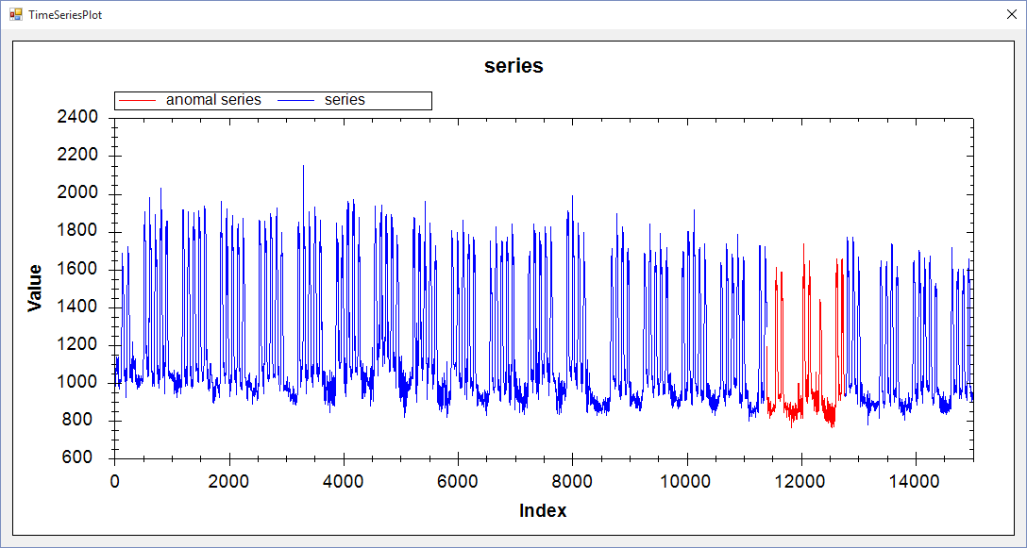

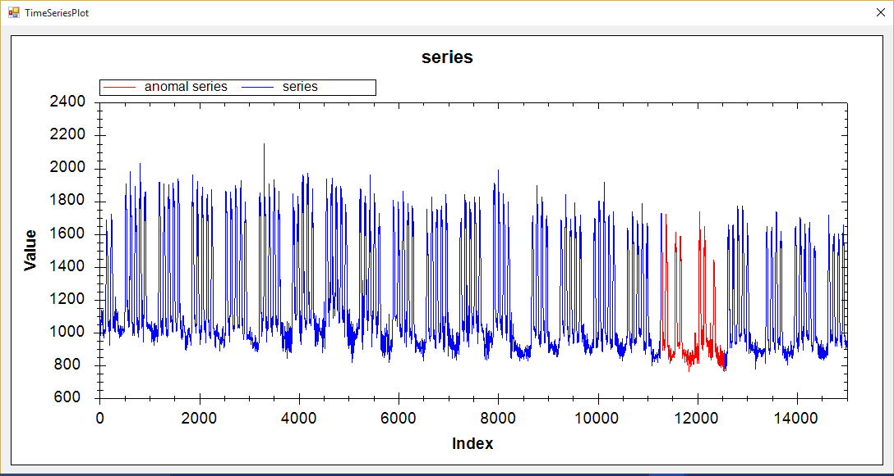

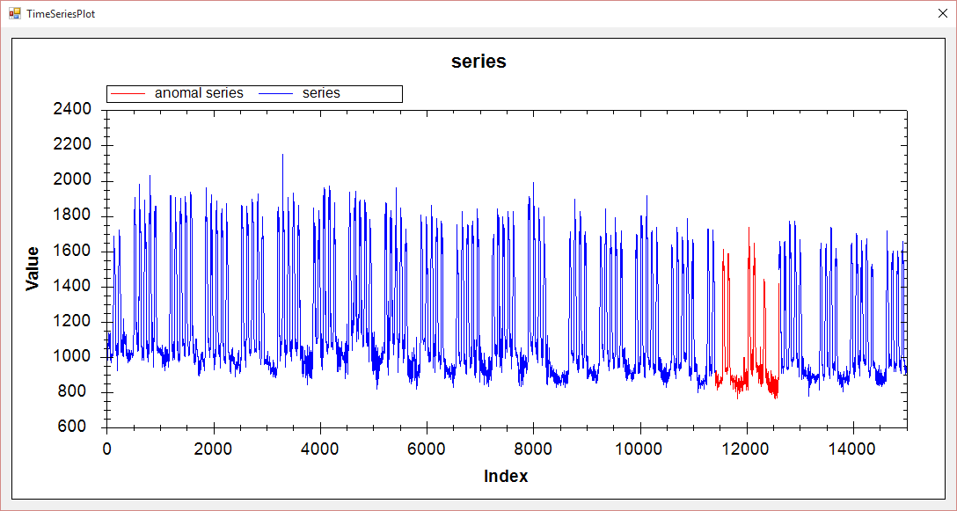

6/ ERP

|  |  |  |  |  |
| --- | --- | --- | --- | --- |
| Algorithm | Data | Param | Anomalies | Time |
| VL with Qudratic | (0-5000) | e1 = 8, e2 = 1.0, k =1, alpha = 2.0 | (2613-2833) | 00:00:08 |
| VL with Extrem Points | (0-5000) | R=1.45,MinLength = 10, k = 1, alpha = 2.0 | (2602-2918)(75-268)(1373-1488) | 00:00:52 |
| HotSax | (0-5000) | Length = 300, PAA Length = 30 | 2518 | 00:00:55 |

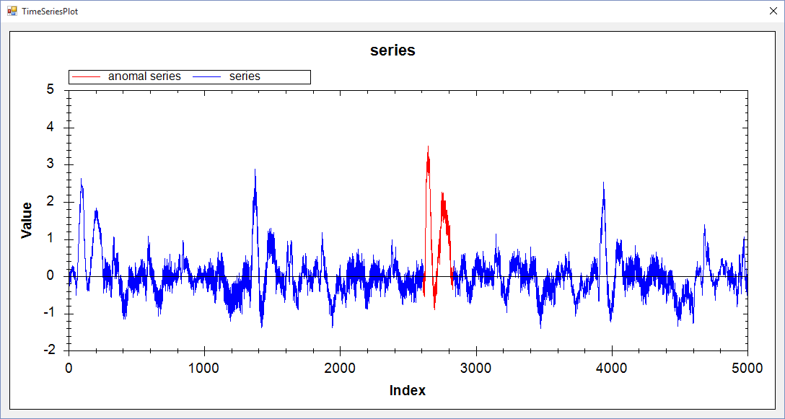

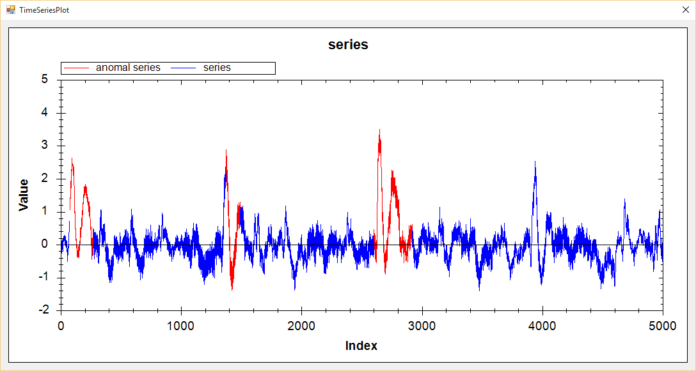

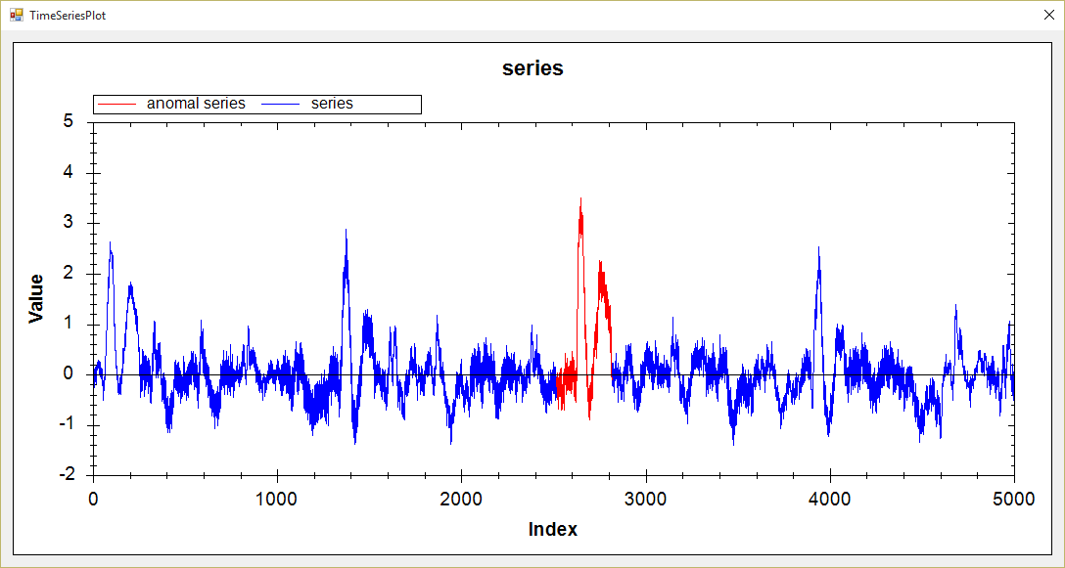

7/ Stock_20

|  |  |  |  |  |
| --- | --- | --- | --- | --- |
| Algorithm | Data | Param | Anomalies | Time |
| VL with Qudratic | (0-5000) | e1 = 2, e2 = 0.1, k =1, alpha = 3.0 | (2961-3667) | 00:00:08 |
| VL with Extrem Points | (0-5000) | R=1.01,MinLength = 200, k = 1, alpha = 1.5 | (2960-3809) | 00:00:09 |
| HotSax | (0-5000) | Length = 700, PAA Length = 70 | 2949 | 00:01:34 |

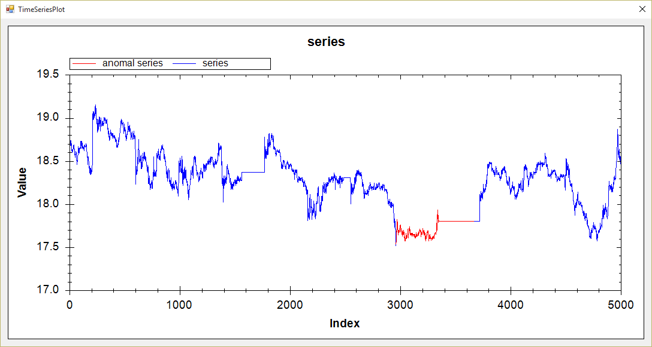

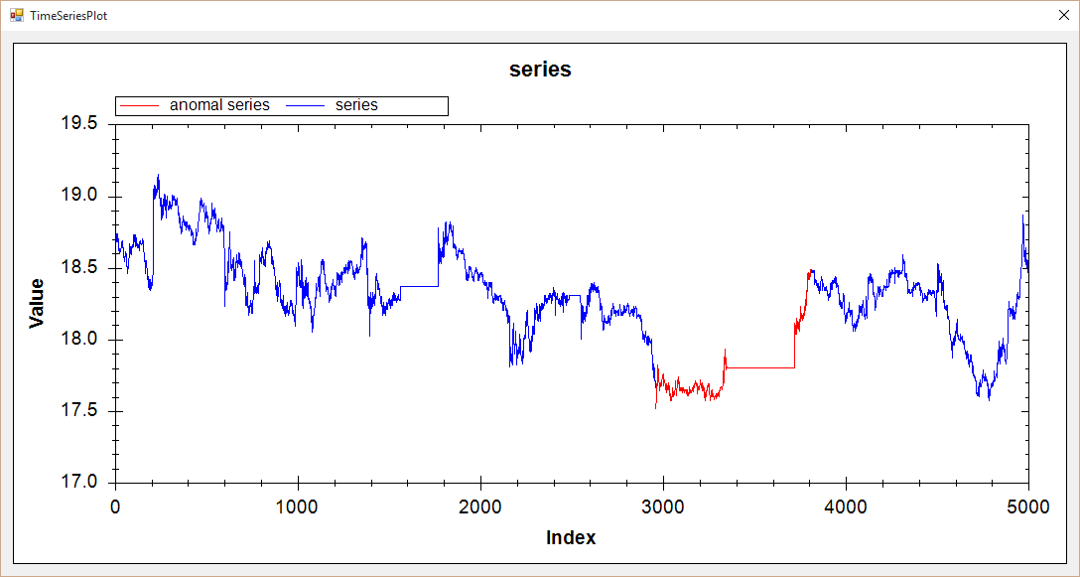

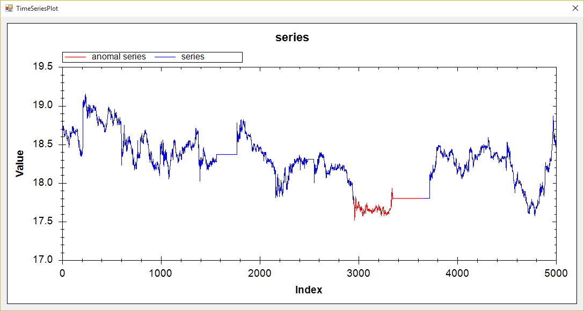

8/ TEK16

|  |  |  |  |  |
| --- | --- | --- | --- | --- |
| Algorithm | Data | Param | Anomalies | Time |
| VL with Qudratic | (0-5000) | e1 = 14.5, e2 = 0.1, k =1, alpha = 2.5 | (4262-4398) | 00:00:13 |
| VL with Extrem Points | (0-5000) | R=1.02,MinLength = 50, k = 1, alpha = 3 | (4197-4470) | 00:00:32 |
| HotSax | (0-5000) | Length = 128, PAA Length = 8 | 4231 | 00:00:52 |

